Hi Armaan,
As we discussed over the phone here are reference to design services pages with content idea and sequence, please find the below, I have given each services link so you will get an idea about that
Services
1) Bookkeeping: https://www.twelixaccounting.com/outsourced-bookkeeping-services
When you see this website there is a lot of content and information on this but we want some of few which is relevant to end client. Please find below
1) Main content of left side with CTA button of Book a free consultation and see what’s include. And right side can we have design or live digit’s we don’t want same but we can try different?
2) Certified on the platforms you already use take this from home page and apply here with rolling format
3)” What Includes in Monthly Fee” content should be same: Content idea you can take from same website but just changed words that should be organic and natural not heavy words so it’s should not be look like a copy paste
4) Software for outsourced solutions with icon take from home page and put here for only accounting software for both country USA and Australia. Now try to rolling software if possible. But don’t mention USA and AUS Platform just software and icon with rolling
5) “Outsourced bookkeeping vs. hiring in-house” – content should be same Idea you can take from same website points should be same but content accordingly
6) How to get started: Please find an example from one of website and draft content accordingly
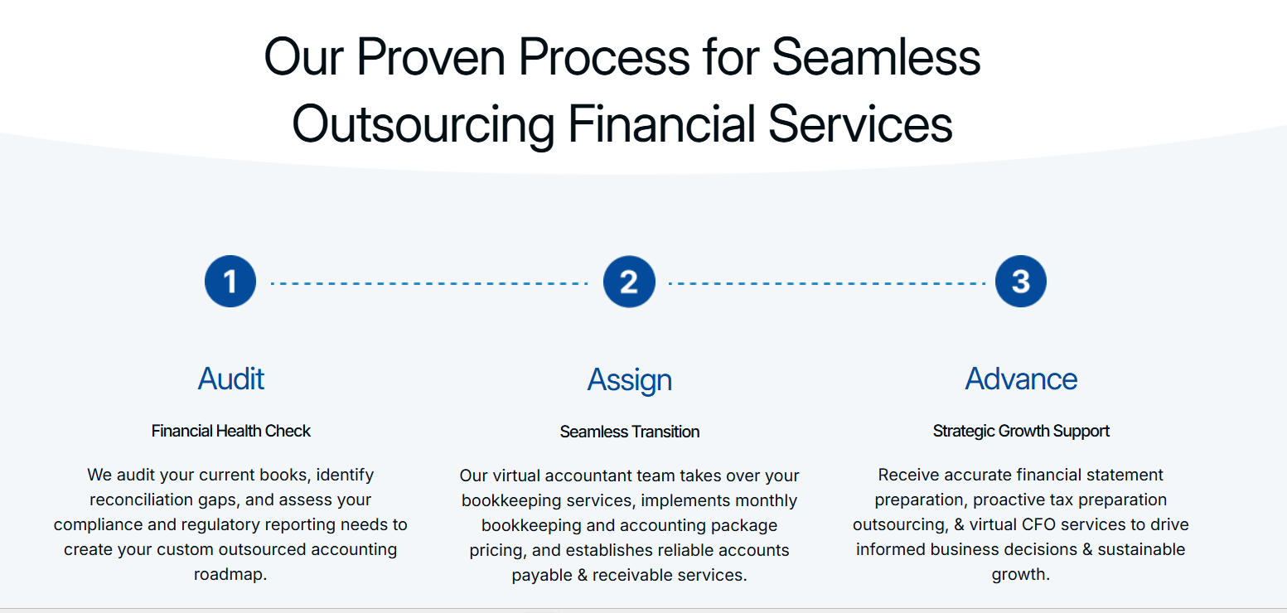
7) Testimonials 2 from USA and 2 From AUS. Now take two testimonials of business owner not CPA firm – Call me once if you not get an idea
8) FAQ’s – required FAQs of 4-5 : Content : https://www.twelixaccounting.com/outsourced-bookkeeping-services https://wachstumkpo.com/outsource-accounting-services/

2) Cleanup and Catch - up services: https://www.twelixaccounting.com/outsourced-bookkeeping-services
1) Main content of left side with CTA button of Book a free consultation and see what a cleanup covers. And right side can we have design we don’t want same but we can try different?
2) Certified on the platforms you already use take this from home page and apply here with rolling format
3) “What catch up bookkeeping services put right”: Content idea you can take from same website but just changed words that should be organic and natural not heavy words so it’s should not be look like a copy paste
4) Software for outsourced solutions with icon take from home page and put here for only accounting software for both country USA and Australia. Now try to rolling software if possible. But don’t mention USA and AUS Platform just software and icon with rolling
5) “Cleanup now vs. leaving it another quarter” : content should be same Idea you can take from same website. Points should be same but content accordingly
6) From first look to clean books, in four steps: Idea should be same but content you can draft and write accordingly also you can take an example as well.
7) Testimonials 2 from USA and 2 From AUS. Now take two testimonials of business owner not CPA firm – Call me once if you not get an idea
8) FAQ’s – required FAQs of 4-5: Content: https://www.twelixaccounting.com/bookkeeping-cleanup-services
3) Tax Preparation: https://www.twelixaccounting.com/tax-preparation-filing-services
1) Main content of left side with CTA button of Book a free consultation and see what tax season covers. And right side can we have design we don’t want same but we can try different?
2) Certified on the platforms you already use take this from home page and apply here with rolling format
3) “Business tax filing services the season actually requires” Main content should be same: In this page there are lots of information available and services those we are not providing we only prepared tax return so please draft content accordingly. We prepared individual and business return
4) Software for outsourced solutions with icon take from home page and put here for only tax software for USA. Now try to rolling software if possible. But don’t mention USA and AUS Platform just software and icon with rolling
5) “Filing from a shoebox vs. filing from closed books”: Content should be same Idea should be same but content you can draft and write accordingly also you can take an example as well.
6) From documents to accepted, in four steps: Idea should be same but content you can draft and write accordingly also you can take an example as well.
7) Testimonials all USA
8) FAQ’s – required FAQs of 4-5: Content: https://www.twelixaccounting.com/tax-preparation-filing-services
4) Sales Tax and Payroll: For these services I have other competitors’ website please research content and get an idea but idea would be same with eight-page content not it’s up to you how you draft content and design for the same. Remembered remote service we are not providing so avoid words
https://safebooksglobal.com/businesses/payroll-sales-tax-filling/
Sequence
1) Main content of left side with CTA button of Book a free consultation and see what sales tax and payroll covers. And right side can we have design we don’t want same but we can try different?
2) Certified on the platforms you already use take this from home page and apply here with rolling format
3) “Sales tax compliance and Payroll services that keeps your business on track” : Main content should be same just draft this same as above services
4) Software for outsourced solutions with icon take from home page and put here for only payroll and sales tax software for USA. Now try to rolling software if possible. But don’t mention USA and AUS Platform just software and icon with rolling
5) “Outsourced Compliance vs. In-House Management”: Content should be same Idea should be same but content you can draft and write accordingly also you can take an example as well.
6) From documents to accepted, in four steps: Idea should be same but content you can draft and write accordingly also you can take an example as well.
7) Testimonials all USA
8) FAQ’s: https://safebooksglobal.com/businesses/payroll-sales-tax-filling/
5) Virtual CFO: Same Idea and page design with eight step content it’s depend on you

